**PROJECT REPORT TEMPLATE TEAM ID –NM2023TMID14303**

1. **INTRODUCTION**
   1. PROJECT OVERVIEW:

This project aim is to maintain and manage the school problems which further can be modified based on the requirements.

We Created

* School Management App
* Objects and fields for App
  1. PURPOSE
* This is customer relationship management, to help you tracking all of your constituent Relationship management, from prospects and students.
* The status of the students is easily available for students.

1. **PROJECT DEFINITION AND DESIGH THINKING**

2.1 EMPATHY MAP

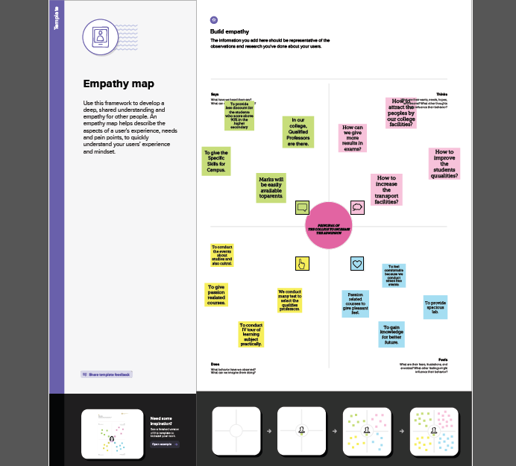

2.2 IDEATION AND BRAINSTORMING MAP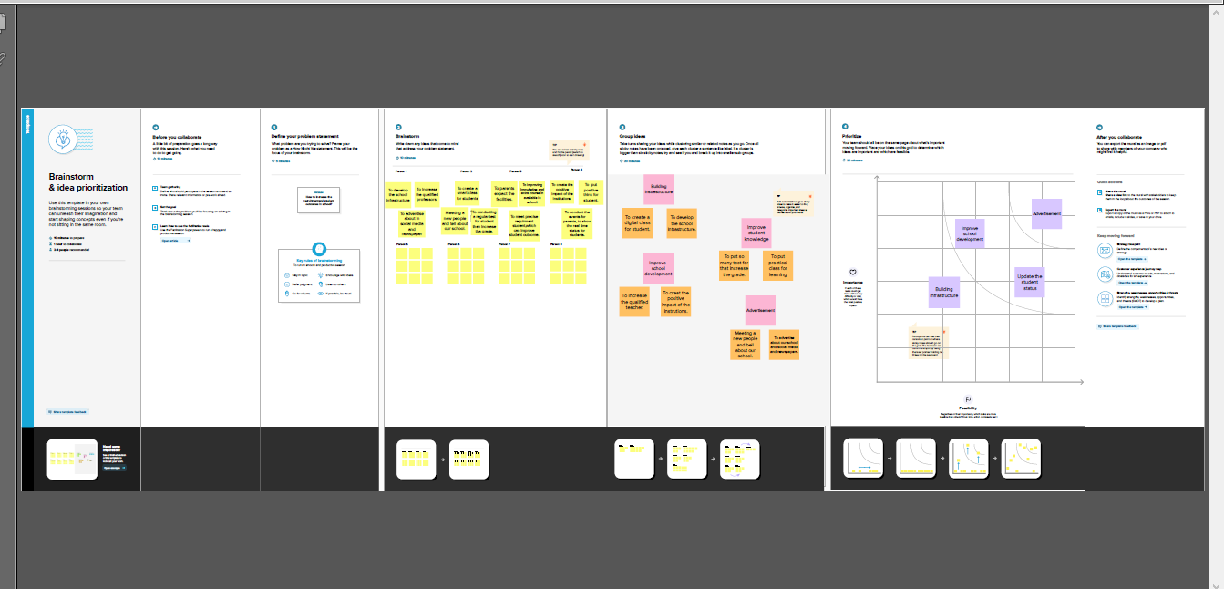

**3. RESULTS**

3.1 DATA MODEL

| **OBJECT**  **NAME** | **FIELD IN THE OBJECT** | | | |
| --- | --- | --- | --- | --- |
| **SCHOOL** |  | **FIELD LABEL** | **DATA TYPE** |  |
| Address | Text Area |
| District | Text Area |
| Highest Marks | Roll-up  Summary  (MAX Student) |
| Number of  Student | Roll-up  Summary  (Count  Student) |
| Phone Number | Phone |
| School Websites | Text Area |
| State | Text Area |

| **STUDENT** |  | **FIELD LABEL** | **DATA TYPE** |  |
| --- | --- | --- | --- | --- |
| Class | Number |
| Marks | Number |
| Phone Number | Phone |
| Results | Pick List |
|  | |
| **PARENT** |  |  | |  |
| **FIELD LABEL** | **DATA TYPE** |
| Parent Address | Text Area |
| Parent Number | Phone |
|  | |

3.2 ACTIVITY AND SCREENSHOT

Milestone-1

Activity 1: (Creating Developer Account)

A developer org is created in salesforce . Signup form is filled and a new user and password is created. Account is activated by the email received and the account gets verified and a developer account gets created.

Milestone-2

Activity 1:(Creating School Object)

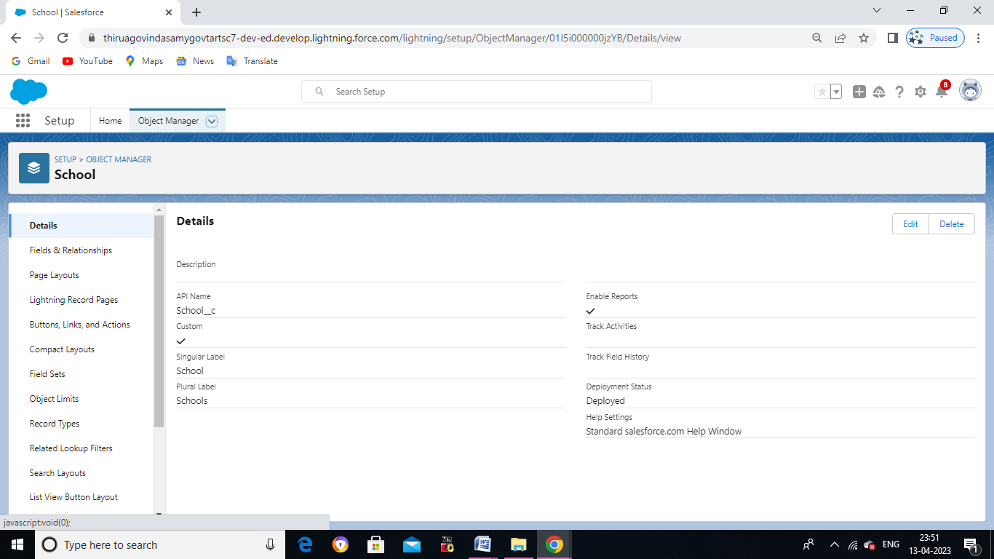

Activity 2: (Creating Student Object)

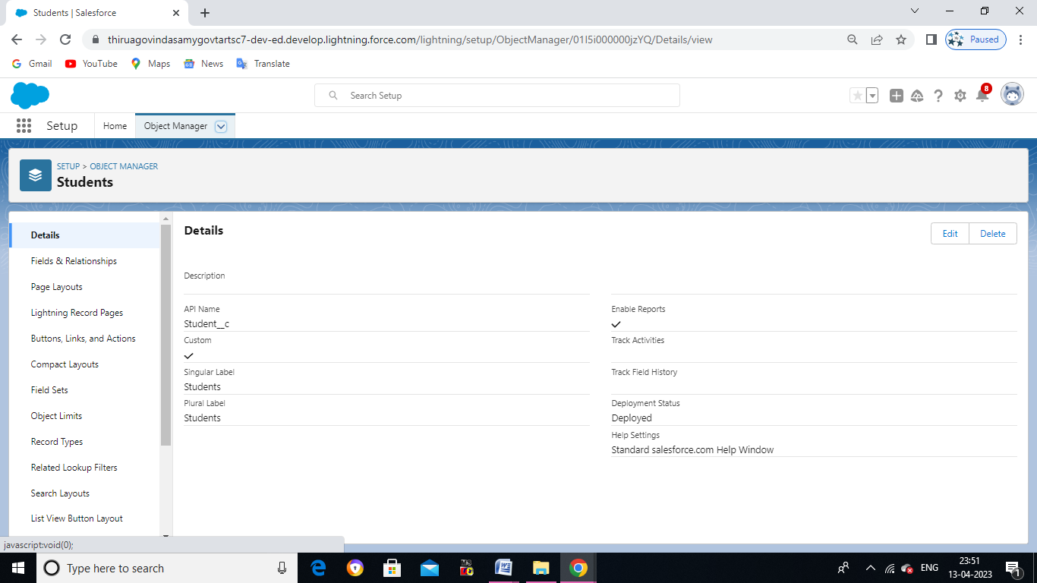

Activity 3: (creating Parent Object)

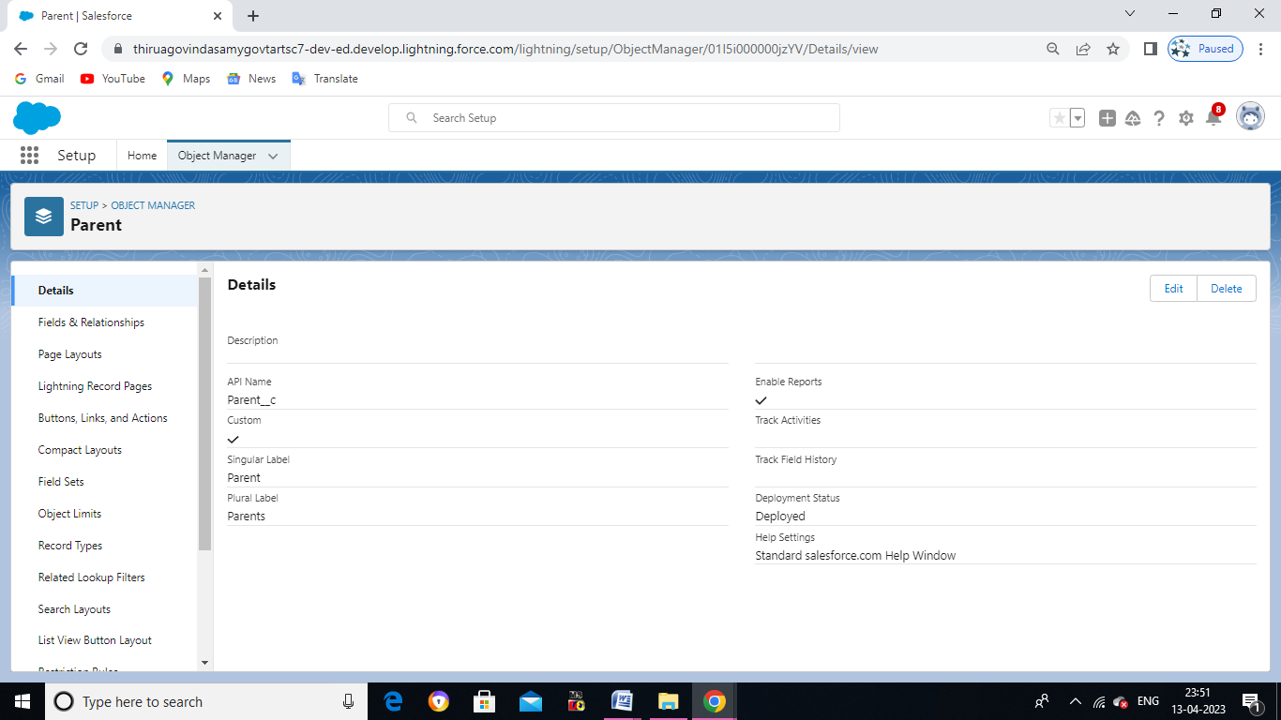

Milestone-3

Activity : (Creating for Lighting App)

* A new lightning app named as SCHOOL MANAGEMENT APP is created. This can be

Viewed in app launcher.

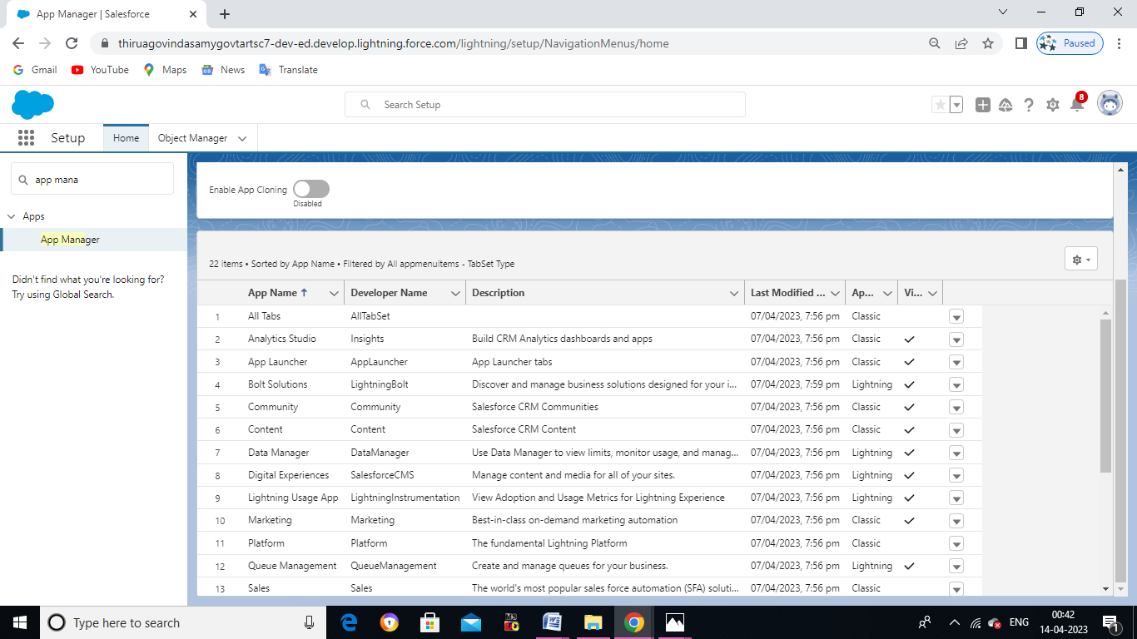

Milestone-4

Activity 1: (Creating for Field and Relationship)

SCHOOL OBJECT:

* School field are using Text Area ,Phone ,Roll-up summary data type’s are created

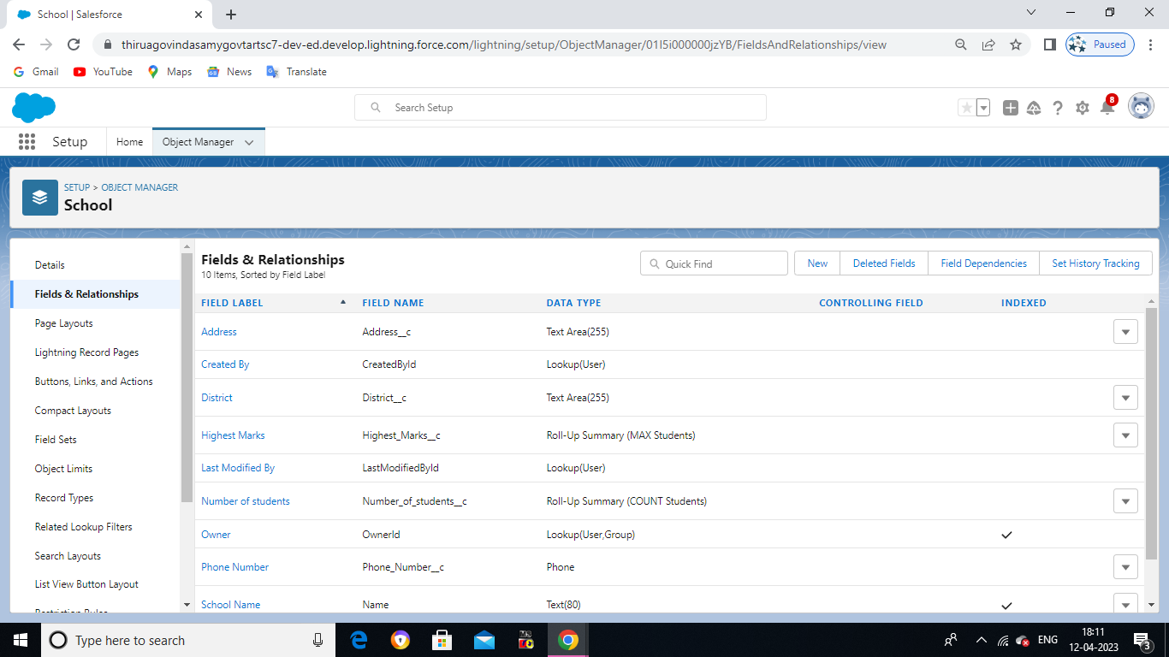

Activity 2:

STUDENT OBJECT:

* Student field using in Phone ,Master-detail ,Pick-List ,Number and Marks data type’s

are created.

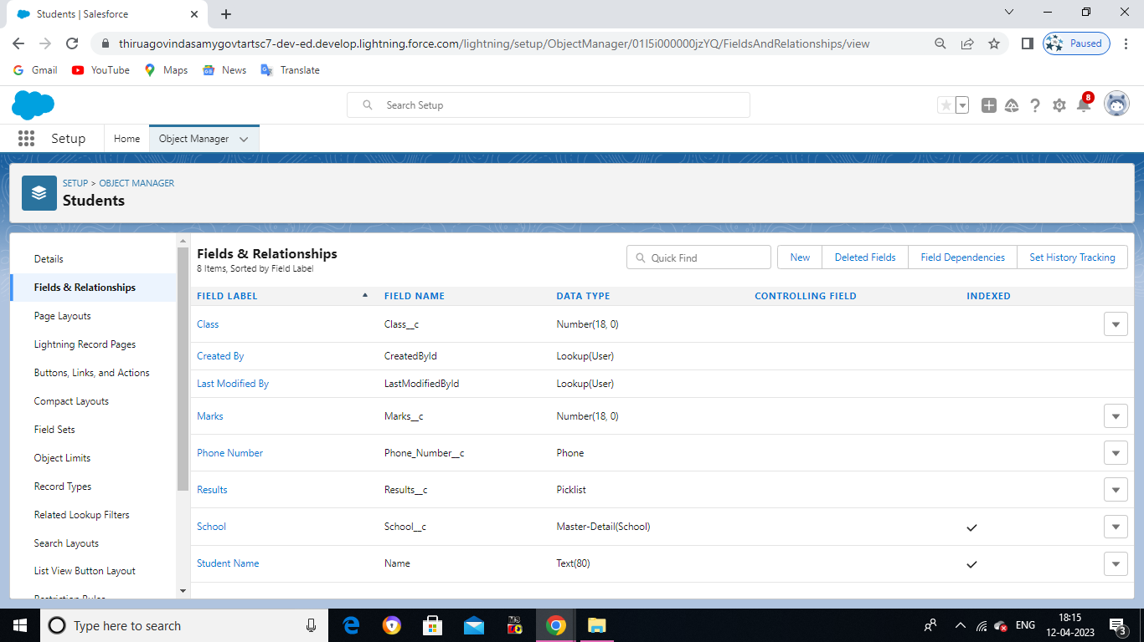

Activity 3:

PARENT OBJECT:

* Parent field using Text Area ,Phone data type are created.

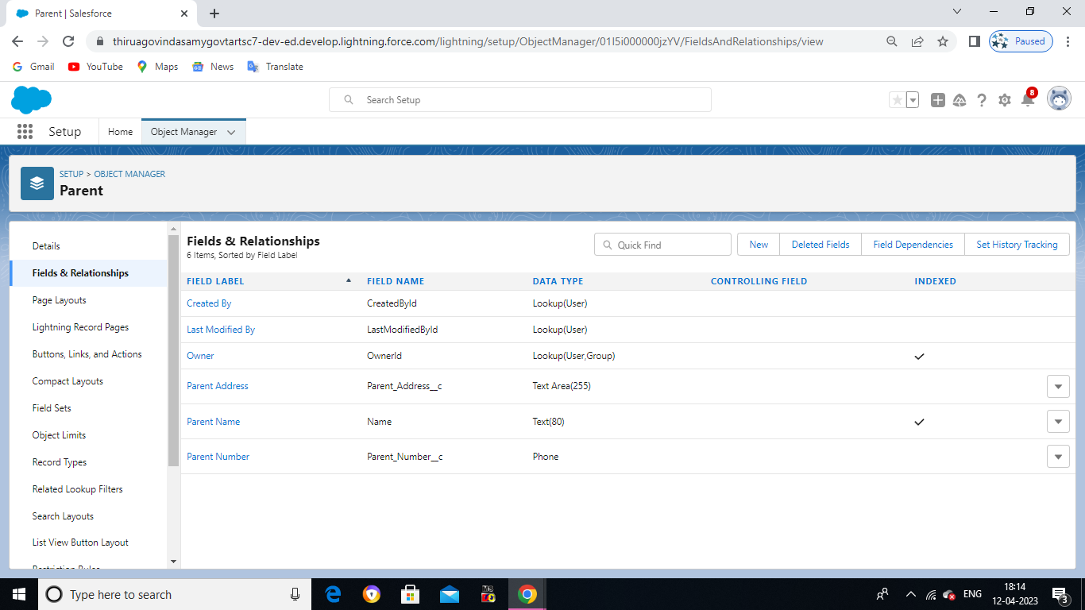

Milestone- 5

Activity: (Creation of Profiles)

* We created in the School Profile.

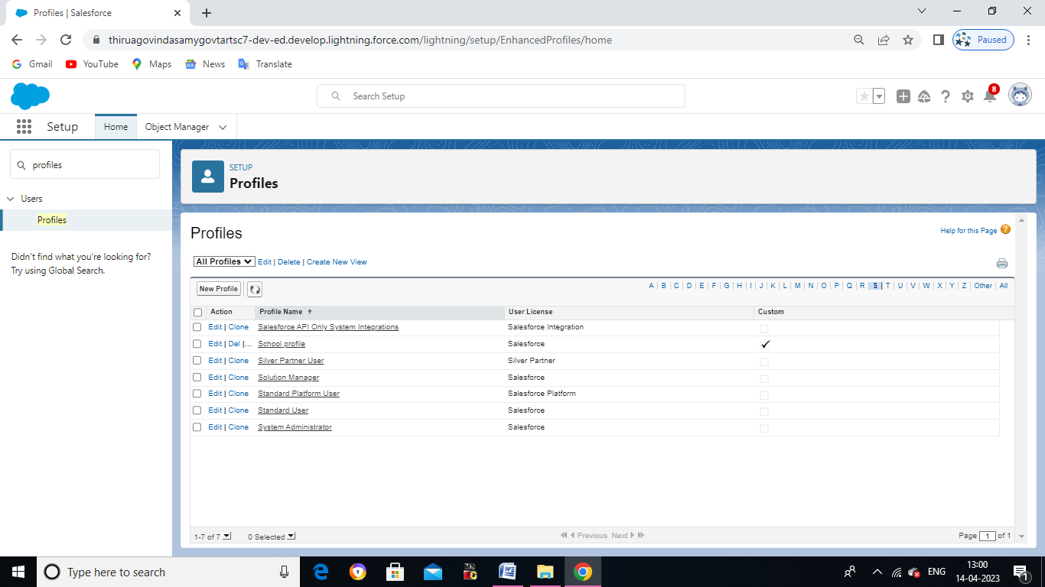

Milestone-6

Activity: (Creating the Users)

* Using the user tab a new profile , salesforce user is created.

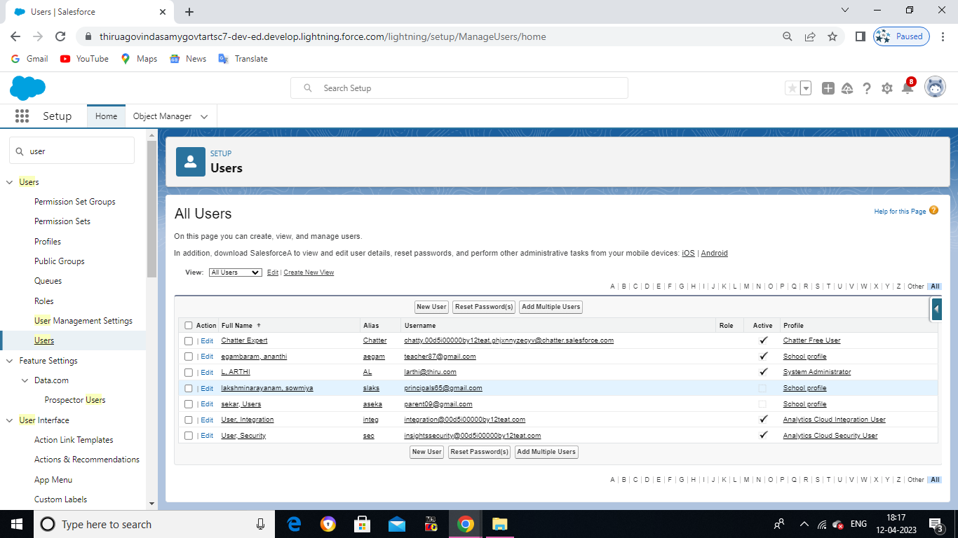

Milestone-7

Activity 1: (Permission sets 1)

* Using the permission tab a new Teacher permission sets is created.

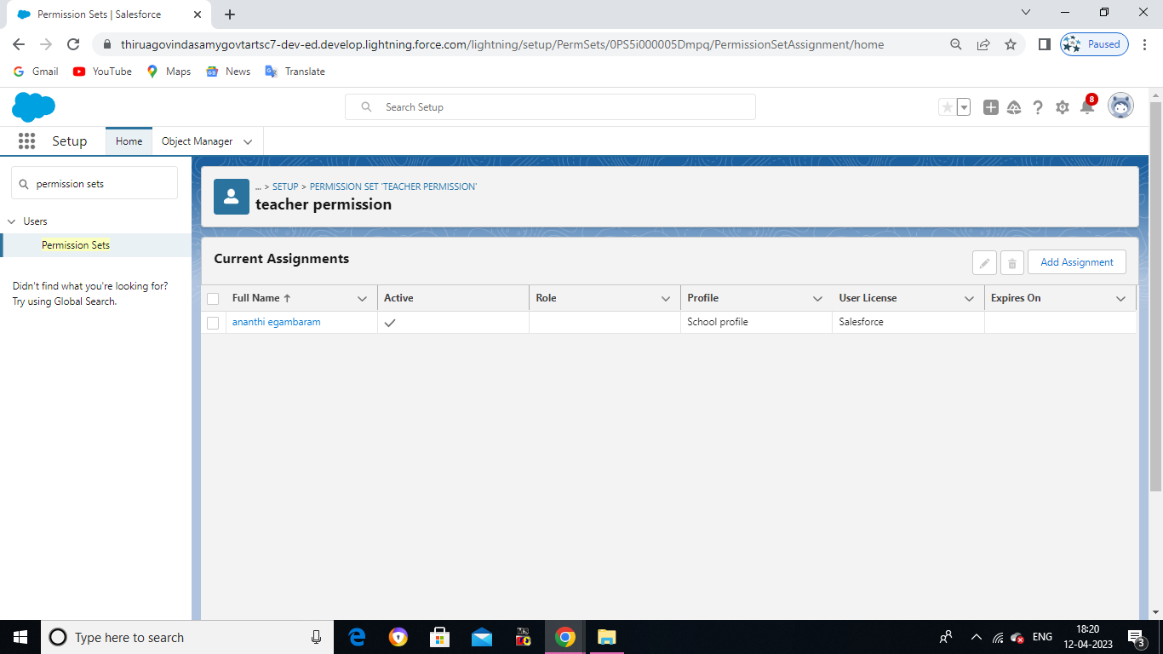

Activity 2: (Permission sets 2)

* Another permission sets is created the Principal Permission sets.

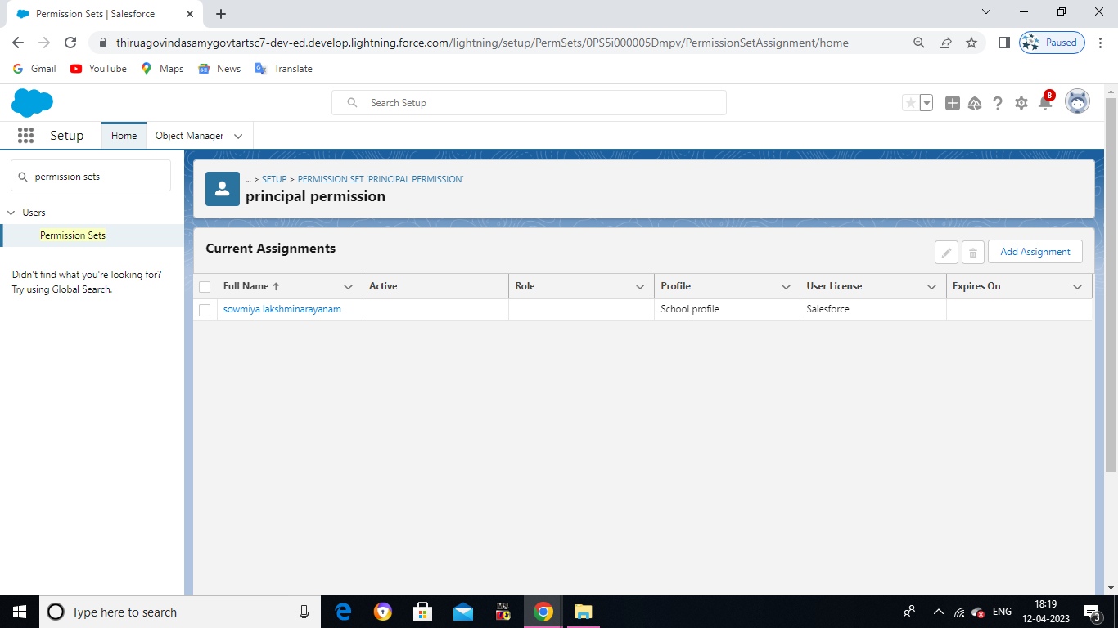

Milestone-8

Activity : (Creating a Report)

* In the reports tab a new report named School with Student and Parent reports are

Created.

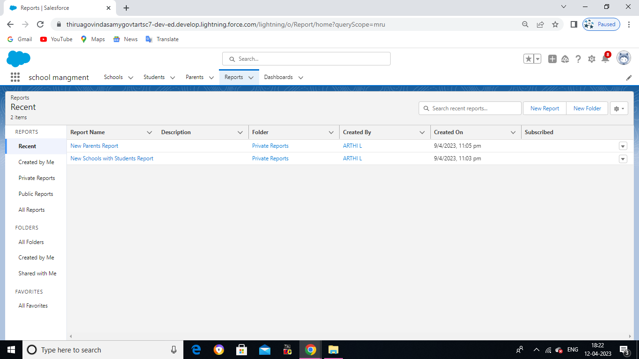

1. **TRAILHEAD PROFILE PUBLIC URL** :

Team Lead-vijay. M-

URL- <https://trailblazer.me/id/vvijay234>

Team member1 - meganadhan. T

URL- <https://trailblazer.me/id/mselvamw222>

Team member2 pranthaman. S

URL-<https://trailblazer.me/id/ssparanthaman22>

Team member3 -rajadurai. S

URL- <https://trailblazer.me/id/rajas318>

Team member4-rajeswari. R

URL- <https://trailblazer.me/id/kkumar2214>

1. **ADVANTAGES AND DISADVANTAGES**:

* Having huge amounts of data on customer interaction enables an

Organization to build up a clearer picture of its customers

.

* All gathered data is stored and maintained as one centralized location

In CRM, which can be easily accessible to see the information

* Not suitable for every business
* They are many security issues with CRM such as data costs and data being hacked by someone.

1. **APPLICATIONS OF CRM:**

* This project helps you to maintain and manage the school related problem.
* This project aim is to provide real-time knowledge for all the student who have

basic knowledge of salesforce.

1. **FUTURE SCOPE:**

* CRM Software helps to generate a progress report on the ongoing tasks in your

enterprises.

* In future CRM Software is used to track all the customers data and records.

1. **CONCLUSION**:

* To created new object and fields.
* It was observed that the presence of effective the level of student report

patronage intention.